

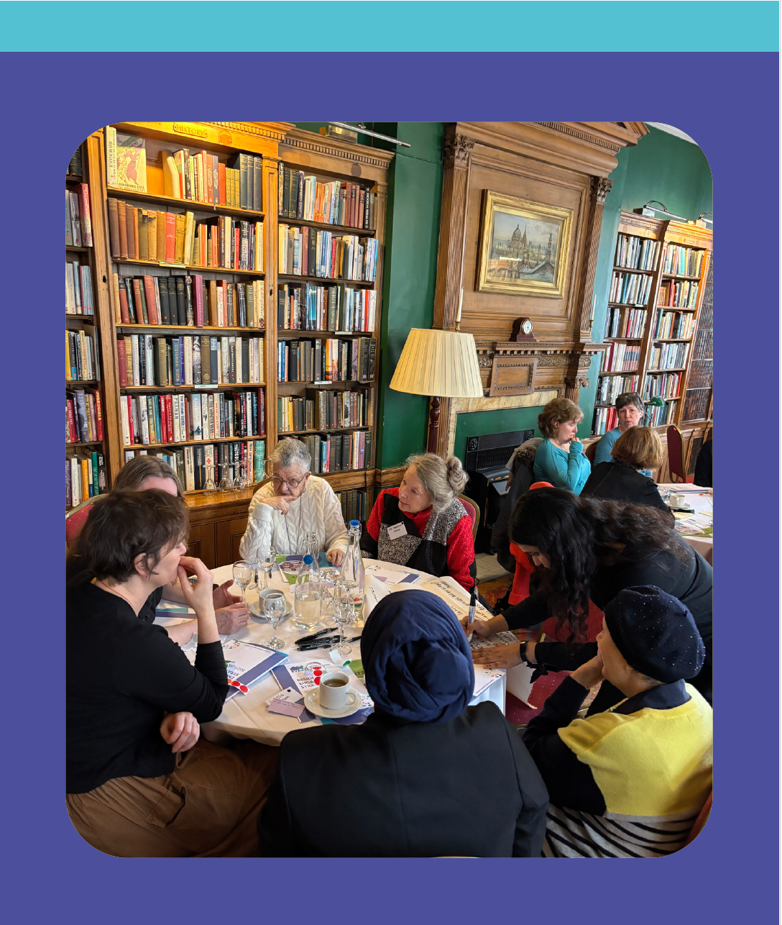
Recruitment information pack
Chair and Committee Chair opportunities


March 2026

Dear applicant

Board opportunities with Women’s Pioneer Housing, Chair and Committee Chair

Thank you for your interest in these rewarding opportunities to join Women’s Pioneer Housing (WPH) which are arising as some of the existing members reach the end of their tenure. The roles are full Board member positions in addition to their Chairing responsibilities.

We enclose information to help you find out more about WPH and the roles of Chair and Committee Chair that WPH are looking to fill, together with details of how to apply. There is of course a wealth of additional information on their website and the annual reports.
We acknowledge all applications, therefore if you do not receive confirmation of receipt within 2 days of submitting your application, please call Heather Taylor on 07779 629455 to ensure that it has arrived safely. Please use a secure email address from which to send your application as our system may filter out emails if it believes them to have been sent from unsecured sites. In order to avoid last-minute IT issues, we also suggest that you allow yourself ample time to submit your application in advance of the deadline.
Applications must be received by Monday 30th March for the Chair of the Board role and Monday 13th April for the Committee Chair posts. Details of the key dates for the recruitment process can be found on page 12 of this information pack.
If you wish to have an informal discussion about either or both roles or if you have any questions, please contact me directly by email in the first instance on sue@foresthr.co.uk.
We look forward to hearing from you and hope that you decide to apply.
Kind regards,
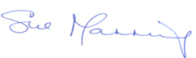

Sue Manning

Director, Forest HR

CONTENTS PAGE
Welcome letter from the current Chair, Ruth Buckingham and the Chief Executive, Tracey Downie | 3
Women’s Pioneer Housing – About us | 5
Chair - Role profile | 6
Committee Chair - Role profile | 8
Key terms and conditions | 11
Outline recruitment process and key dates | 12
A full copy of this information pack, the Equality and Diversity Monitoring form can be downloaded from:
www.foresthr.co.uk/recruitment
and the link for the Annual Report 2024 is available on the Wome’s Pioneer site at:
Annual Report 2024

WELCOME LETTER

Board opportunities with Women’s Pioneer Housing: Chair and Committee Chairs

We are delighted that you are considering joining our Board.

Women’s Pioneer Housing has an extraordinary legacy. We were founded in 1920 by
women and men who understood the link between providing women with good quality
affordable accommodation and the wider fight for women’s equality. We have always held true to this mission and after 100 years since our formation, gender inequality remains a huge issue.

A safe home is the foundation in supporting our residents’ independence. A women’s life is a journey and we need to be able to support our residents along the way. We do this in many ways. We house women of all ages, and we are the largest provider of sheltered housing in Kensington and Chelsea. We work closely with our residents to review and continuously improve our homes and services and our Chair must be committed to ensuring our residents influence our services, supporting our resident Board members and engaging with our Resident Scrutiny Panel.

These are exciting times for Women's Pioneer Housing. We are nearing completion of an ambitious development programme having achieved planning permission for our first two major developments 3 years ago. Both these developments will be available in 2026 and will provide homes for over 160 single women in Hammersmith & Fulham and Ealing. Our development in Hammersmith & Fulham will also provide a brand-new head office, which we will move to during October 2026.

In 2024 we received a prestigious award for Planning for Affordable Housing for our flagship development scheme in Hammersmith & Fulham, which recognised the most impactful efforts in increasing the provision of affordable housing for single women, significantly improving access to below market cost homes. The award also recognised environmental quality and the innovative approach and dedication to address housing affordability which set a benchmark in the industry. This success realises our continuing efforts to be a leading voice on women’s housing issues, raising awareness of gender inequality and intersecting inequalities linked to race, sex and sexual orientation, disability, age etc. In 2026 the need to address women’ diverse housing needs is perhaps just as great as it was in 1920.

We have a strong management team who are infusing energy into our organisation and inspiring our people to embrace change. Our teams work collaboratively, and your leadership style should reflect this approach.

Our Board is diverse and incredibly committed. We have a robust governance structure in place, essential as we undertake new opportunities, manage our growth and prepare to exceed the 1,000 homes threshold and undertake our first regulatory inspection.

As a chair/committee chair you will support and contribute to what is an exciting period of change and growth for us. We are specifically looking for professionals with work experience drawn from housing, with expertise in governance and experience at Executive and Board level. Your ability to demonstrate confident leadership in achieving collective strategic decisions and working creatively with others will be evident. Ideally you will have had experience of chairing a committee or board and we especially welcome interest from candidates with lived experience of, or a personal connection to our founding purpose and values.

If you are motivated by our values, committed to excellent governance, and ready to lead with integrity and ambition, we would be delighted to hear from you,

Ruth Buckingham TLDownie
Ruth Buckingham Tracey Downie
Chair CEO
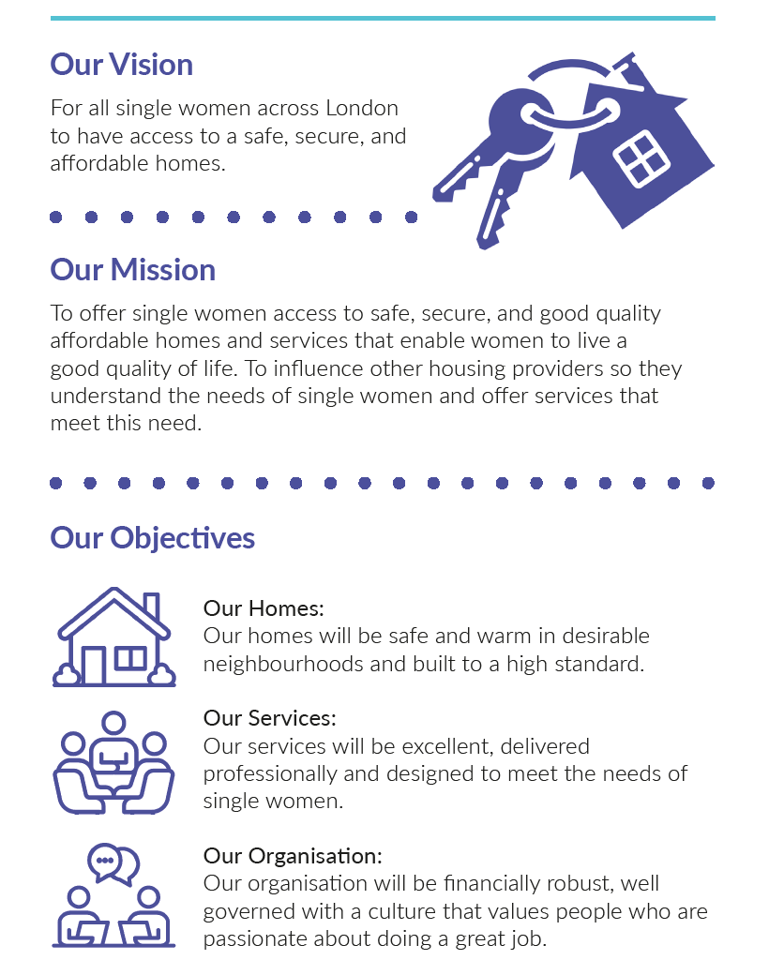
ABOUT US
CHAIR - ROLE PROFILE
Purpose:

To provide leadership to our Board in developing and overseeing our strategic direction, governance, monitoring and performance, and to inspire and motivate the Board and all of our executives, senior management and colleagues, to work towards and deliver our vision and mission.
The Chair will ensure that our Committees are clear on their accountabilities, work with appropriate delegations, operate effectively and all are working collectively to contribute to the achievement of our overall aims and objectives.
Oversee governance and ensure WPH is managed with probity and integrity, and complies with statutory and any applicable regulatory duties.
Key Duties and Responsibilities:
Lead the Board in:
- Defining, upholding and, where necessary, updating our mission, values, strategies, objectives and policies.
- Scrutinising and reviewing our performance against agreed targets and budgets, also in respect of resident engagement and feedback.
- Ensure meetings take place with appropriate timings and Board resolutions are properly managed, and any required, necessary decisions are made and implemented.
- Providing a creative, informed and challenging contribution.
Chairing our Board meetings, and any General Meetings, and ensuring:
- Business is conducted efficiently, fairly and effectively through a framework of delegation and systems of internal control and assurance.
- Agendas are agreed in advance and with appropriate consultation.
- All Board members are given the opportunity to express their views, contributions are timely and relevant, and appropriate standards of behaviour are maintained; and
- Subsequently to ensure that the minutes are an accurate reflection of the discussions.
Ensure, through the Chief Executive, that WPH is managed efficiently, fairly and effectively and that our structure, resources and capabilities are appropriate to execute our aims and objectives.
Ensure appropriate and effective Board member appraisal, development and support arrangements are in place and carried out.
Act as a role model for good governance practices and behaviours.
Skills and Experience:
- Have recently operated at executive level in social housing.
- A track record of leading and working in teams to develop and deliver high performance and strategic objectives.
- Have 3 years’ experience on a Board in a regulated sector.
- Have experience of Chairing a Committee in a regulated sector and experience of Chairing a Board would be an advantage.
- Have experience of the social housing regulatory regime at executive level.
- Ideally have experience of regulatory inspections, including the consumer standard.
- Ideally have a professional background in areas such as governance, housing or asset management, and related customer services and an excellent understanding of the environment and market that we operate in.
- Have a range of skills and experience relevant to Chairing a Board including financial literacy, strategic thinking, understanding how to achieve good governance, how to assess and manage risk and assurance, etc.
- The ability and experience to develop collaborative and strong working relationships and to work effectively with a wide range of stakeholders to work together to achieve common goals and shared objectives.
- An effective and competent leader who is also able to be a role model.
- The ability to demonstrate strong commitment to equality and diversity.
- Able to create a culture of joint responsibility, encouraging debate and consensual decision making.

COMMITTEE CHAIR - ROLE PROFILE

Purpose:

To provide leadership to the committee, bringing the specific skills and experience for the relevant committee and taking a lead role to ensure that the work of the committee is carried out effectively.
Ensure that the committee members clear on their accountabilities, work with appropriate delegations, operate effectively and all are working collectively to contribute to the achievement of our overall aims and objectives.
The Committee Chair will bring their recent and relevant board, executive, board and professional skills and experience to te role to encourage, shape and deliver best practice and ensure that the committee is managed with probity and integrity, and complies with statutory and any applicable regulatory duties.
Key Duties and Responsibilities:
Lead the Committee in:
- Defining, upholding and, where necessary, updating the relevant strategies, objectives and policies that are within the remit of the committee.
- Scrutinising and reviewing our performance against agreed targets and budgets, also in respect of resident engagement and feedback.
- Ensure meetings take place at appropriate timings and Committee decisions and recommendations to Board are properly managed.
- Providing a creative, informed and challenging contribution.
Chairing the Committee meetings, and ensuring:
- Business is conducted efficiently, fairly and effectively through a framework of delegation and systems of internal control and assurance.
- Agendas are agreed in advance and in consultation with the appropriate persons.
- All Committee members are given the opportunity to express their views, contributions are timely and relevant, and appropriate standards of behaviour are maintained; and
- Subsequently to ensure that the minutes are an accurate reflection of the discussions.
Contribute, through the Chair of the Board, to the effective management of WPH.
Ensure appropriate and effective Committee member appraisal, development and support arrangements are in place and carried out.
Act as a role model for good governance practices and behaviours.

Skills and Experience:
- Have recently operated at executive level in social housing or similar relevant sector.
- A track record of working in, and leading teams to develop and deliver high performance and strategic objectives.
- Have 12 months’ experience on a Board in a similar or relevant regulated sector.
- Ideally have experience of chairing a committee.
- Have a relevant professional background, and ideally associated qualifications, that are relevant to the appropriate committee which are detailed below. CIOH is a welcome addition for all members and chairs.
- Have a range of skills and experience relevant to Chairing a Committee and actively contributing to the Board including financial literacy, strategic thinking, understanding how to achieve good governance, how to assess and manage risk and assurance, etc.
- The ability and experience to develop collaborative and strong working relationships and to work effectively with a wide range of stakeholders to work together to achieve common goals and shared objectives.
- The ability to demonstrate strong commitment to equality and diversity.
- Able to create a culture of joint responsibility, encouraging debate and consensual decision making.
Each Committee would require or value a relevant range of qualifications and experience:
Audit & Risk (ARC)
The Committee Chair will need to be a qualified accountant.
Additional useful skills and experience include:
- Essential - Sound knowledge and proven experience in audit & risk.
- Ideally – Risk management experience at a senior level in a relevant regulated sector.
- Provide WPH with independent assurance that WPH has adequate internal financial controle and risk management processes in place that ensures appropriate financial management.
- Review and fulfil statutory and regulatory requirements in terms of risk management and assurance.
Development & Asset Management (DAMC)
The Committee Chair will ideally offer qualifications relevant to property and development such as CIOB, RICS or RIBA.
Additional useful skills and experience include:
- Essential - Managed or developed HRBs at a senior level in the social housing sector.
- Ideally – relevant experience for housing asset management and development including project management, risk management and or financial appraisal of construction project analysis.
People & Governance Committee (PaGC)
Skills and experience requirements include:
- Essential - Knowledge of employment law and practice from operating at a senior level.
- Ideally – a relevant qualification such as CIPD.
- Essential - 12 month’s experience of governance in a social housing context, at Board or Executive level.
- Ideally – proven experience in recruitment and selection practive.

CORE COMPETENCIES, STRATEGIC LEADERSHIP AND EQUALITY & DIVERSITY

- An understanding of the environment and market in which WPH operates.
- A strong understanding of the housing sector, market conditions and regulatory frameworks.
- An understanding of WPH's governance structure.
- Experience of working in collaboration with others, working towards common goals and
- shared objectives.
- Track record of managing performance.
- Has a successful track record of leadership having operated and contributed effectively at a senior level in either the private/public, voluntary or community sectors.

KEY TERMS AND CONDITIONS
(For information purposes only)

Appointment | The initial term of this post is for a three-year appointment. A subsequent term may be made at the expiration of the first.  Generally, the continuous period of service will not exceed six years unless there are exceptional circumstances.
Probation | A period of six months’ probation will apply.
Personal development | To enable the proper fulfillment of the post we will encourage and provide opportunities for the post holder to develop and expand their knowledge and skills.  Post holders are expected to demonstrate a commitment to continuous personal development.
Fees | All fees are per annum:  Chair £7,000  Committee Chair, £3,750.  Board and Committee fees are paid in 12 equal monthly payments and credited to the post holder’s bank account.  In addition, Board and Committee Members may claim reasonable out of pocket expenses, as outlined in the section below.
Travel | Travel costs to and from our offices is non-reimbursable (to meet current HMRC rules), but reasonable expenses will be paid for travel to training courses and conferences approved by us in advance.  Board and Committee Members may claim car mileage at the prevailing HMRC rate.  We will meet claims for car parking fees if free parking is not available when attending external events on our behalf.

OUTLINE PROCESS AND KEY DATES

How to apply: | Download the information pack, from  www.foresthr.co.uk/recruitment  Please apply by providing:  - An up to date CV covering both your leadership experience together with experience in non-executive roles.  - A brief supporting statement, which covers your reason for applying and how you feel you meet our requirements.  - Not part of the formal selection process, it would also be appreciated if you could complete the equal opportunity monitoring and declaration of interests' forms. Copies of these forms are available for you to download separately.  Please indicate which role(s) you are interested in i.e Chair and/or Committee Chair, and confirm the specific Committee Chair role you are applying for.  You are welcome to apply for more than one post. The Chair of the Board recruitment will be taking place first.  Please send your application to talent@foresthr.co.uk
Chair recruitment timetable
Closing date: | Monday 30th March 2026
Initial interviews:  Final selection process: | w/c Tuesday, 7th April 2026 (virtual)  Wednesday 23rd April (on site)
Approval of appointment | End of May 2026
Observe board meeting | 4th June 2026
Confirmation of appointment & | AGM - 24th June 2026
Start | 24th June 2026
Committee Chair recruitment timetable
Closing date: | Noon, Monday 13th April 2026
The timetable will follow the Chair recruitment to involve the designate appointee.

